|  |  |
| --- | --- |
|  | **Cognizant Academy**  **truYum**  **C# Specification Document**  **Version 1.0** |
| |  |  |  |  | | --- | --- | --- | --- | |  | **Prepared By / Last Updated By** | **Reviewed By** | **Approved By** | | **Name** | Ramamoorthy Selvam | Vimalathithan Krishnan | Ramadevanahalli Lingachar, Shashidhara Murthy | | **Role** | Learning Solution Designer | Learning Solution Architect | Learning Solution Lead | | **Signature** |  |  |  | | **Date** |  |  |  | |
|  |

Table of Contents

1.0 Introduction 4

1.1 Purpose of this document 4

1.2 Definitions & Acronyms 4

1.3 Project Overview 4

1.4 Scope 4

1.5 Intended Audience 4

1.6 Hardware and Software Requirement 4

1.7 Visual Studio 2015 Project Configuration 5

2.0 Class Diagram 5

2.1 Com.Cognizant.Truyum.Model Namespace 5

2.1.1 Namespace creation 6

2.2 Utility Namespace 6

2.2.1 Namespace creation 6

2.2.2 DateUtility.cs 7

2.3 Com.Cognizant.Truyum.Dao namespace 7

2.3.1 Namespace creation 7

3.0 Design for View Menu Item List Admin (EKUC001) 9

3.1 Class Diagram 9

3.2 IMenuItemDao.cs 9

3.3 MenuItemDaoCollection.cs 10

3.4 MenuItemDaoCollectionTest.cs 10

4.0 Design for View Menu Item List Customer (EKUC002) 12

4.1 Class Diagram 12

4.2 IMenuItemDao.cs 12

4.3 MenuItemDaoCollection.cs 13

4.4 MenuItemDaoTest.cs 13

5.0 Design for Edit Menu Item (EKUC003) 14

5.1 Class Diagram 14

5.2 IMenuItemDao.cs 14

5.3 MenuItemDaoCollection.cs 15

5.4 IMenuItemDao.cs 15

6.0 Design for Add to Cart (EKUC004) 16

6.1 Class Diagram 16

6.2 ICartDao.cs 16

6.3 CartDaoCollection.cs 16

7.0 Design for View Cart (EKUC005) 18

7.1 Class Diagram 18

7.2 ICartDao.cs 18

7.3 CartEmptyException.cs 18

7.4 CartDaoCollection.cs 19

7.5 CartDaoCollectionTest.cs 19

8.0 Design for Remove Cart Item (EKUC006) 20

8.1 Class Diagram 20

8.2 ICartDao.cs 20

8.3 CartDaoCollection.cs 20

8.4 CartDaoCollectionTest.cs 21

9.0 Standards and Guidelines 21

9.1 C# 21

10.0 Console application to test C# class library ( Com.Cognizant.Truyum.Model & Com.Cognizant.Truyum.Dao ) 23

11.0 Submission 23

11.1 Code submission instructions 23

12.0 Change Log 24

# Introduction

## Purpose of this document

The purpose of this document is to define the C# classes related implementation for truYum project.

## Definitions & Acronyms

|  |  |
| --- | --- |
| Definition / Acronym | Description |
| ADO.Net | ActiveX Data Objects (ADO.NET) is a framework that contains set of classes to interact with Datasources such as SQL Server and XML. |

## Project Overview

Refer Use Case specification document for understanding the functionality and features.



## Scope

Creation of model and data access object classes for truYum application

## Intended Audience

* Product Owner
* Scrum Master
* Application Architect
* Project Manager
* Test Manager
* Development Team
* Testing Team

## Hardware and Software Requirement

1. Hardware Requirement:
   1. Developer PC with 8GB RAM
2. Software Requirement
   1. Git
   2. IE or Chrome
   3. .Net Framework 4.5
   4. Visual Studio Professional Edition 2015
   5. SQL Server enterprise edition 2014

## Visual Studio 2015 Project Configuration

The project cloned from Git needs to be set up as Visual Studio project to make it easier with C# development. Find below the steps to configure Visual Studio for the truYum project.

1. Open Visual Studio 2015
2. File > Open > Project/Solution
3. Select the truYumOnline folder in your PC where the truYum code was cloned from <https://code.cognizant.com>
4. Select the solution file ( .sln) to load the project in Visual Studio 2015 IDE.
5. After successful loading of the project, the project folder/files can been seen in the solution explorer available on the left hand side.

# Class Diagram

The classes specified in this document are the primary C# classes that are required for implementation of truYum application. Since ADO.NET module is covered later, the actual database implementation details are postponed to the respective module. The classes in this specification are implemented with hardcoded values and will be consumed by the ASP.NET pages when implementing the next module.

## **Com.Cognizant.Truyum.Model** Namespace

Following are the real world objects identified for truYum application. Menu Item refers to a menu item available for sale in truYum. Cart will represent customer’s cart to hold the selected menu items. Refer the diagram below and create classes accordingly.

### Namespace creation

Create class library **Com.Cognizant.Truyum.Model** with the member variables given below

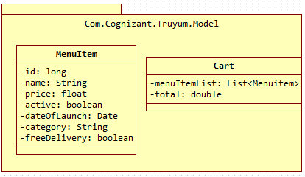

Guidelines for understanding the above class diagram:

1. “Com.Cognizant.Truyum.Model” represents the namespace
2. MenuItem and Cart are classes
3. The content within MenuItem are instance variables
4. The hypen in each line represents private access specifier
5. For the sake of simplicity the constructors, Properties are not included in the diagram. But it needs to be implemented in code.
   1. Constructor with option to set all instance variables
   2. Properties for each instance variable
   3. Generate ToString() method
   4. Generate Equals() method which checks for equality based on the ‘id’ attribute

## **Utility** Namespace

### Namespace creation

Create class library **Com.Cognizant.Truyum.Utility** with the method given below.

Common reusable classes and methods across truYum application will be included in this namespace.

### DateUtility.cs

As per the below Class diagram, create a method in this class to convert the input date string to shortDateString

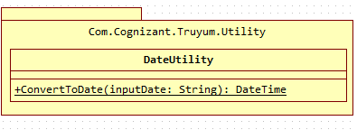

**ConvertToShortDateString(string inputDate) of return type DateTime**

This method is used to convert the input date entered in string format to Datetime.

1. Use DateTime.Parse(inputDate) to convert the input string to DateTime.

## **Com.Cognizant.Truyum.Dao** namespace

This namespace contains the list of classes that will code to manage the data for truYum application. The methods in Dao classes will be tested using MenuItemDaoCollectionTest and CartDaoCollectionTest classes. The Dao interface classes will act as a contract for working with any database. In this specification the implementation of MenuItemDaoCollection and CartDaoCollection will be Collection framework based implementation of Dao interfaces MenuItemDao and CartDao.

## **2.3.1** Namespace creation

Create class library **Com.Cognizant.Truyum.Dao** and create the classes listed in the diagram within this namespace



Guidelines for understanding the above class diagram:

1. Identify the namespace, classes, access modifiers, methods and static methods from the above diagram.
2. IMenuItemDao and ICartDao are interfaces
3. MenuItemDaoCollection and CartDaoCollection are implementation classes for the interfaces as denoted by the dotted arrow line.
4. MenuItemDaoCollectionTest and CartDaoCollectionTest are implementation classes for testing MenuItemDaoCollection and CartDaoCollection.
5. MenuItemDaoSql, CartDaoSql, MenuItemDaoSqlTest, CartDaoSqlTest classes will not be implemented in this module. Please ignore these classes for this module.
6. CartEmptyException is an exception class that extends System.Exception.
7. Highlighted classes will be implemented in this module.

# Design for View Menu Item List Admin (EKUC001)

## Class Diagram

The below diagram denotes the methods that needs to be implemented for this use case. Method wise specification is defined after the diagram.

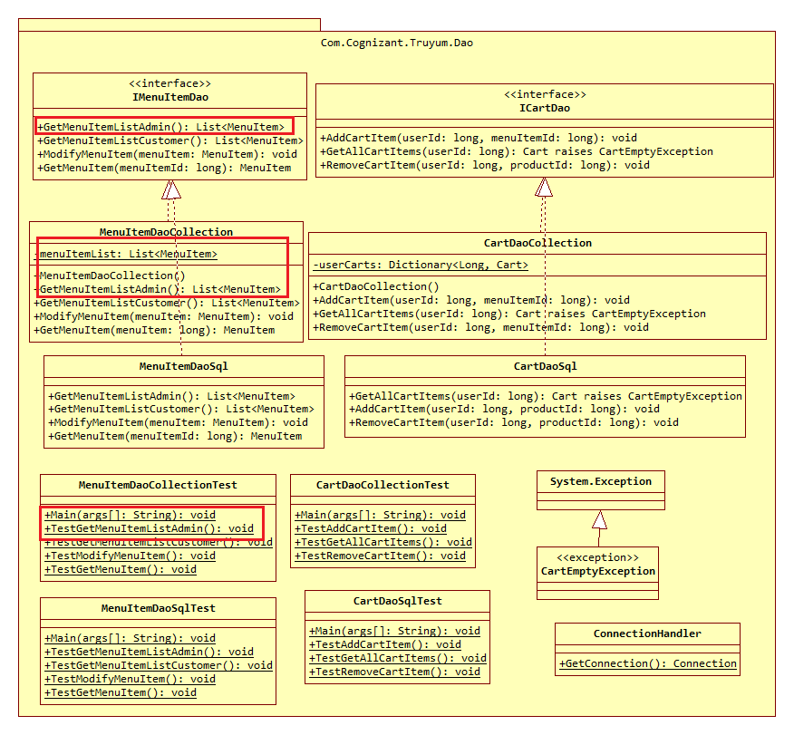

## IMenuItemDao.cs

Add the method GetMenuItemListAdmin() with return type List<MenuItem> in the interface.

## MenuItemDaoCollection.cs

Class for managing data of menu items using C# Collections Framework.

**Constructor**

The objective of this constructor is to initialize the menu item data that will be displayed in MenuItem listing screen of Admin.

1. Check if menuItemList variable is null or not
2. If it is null perform the steps below:
   1. Create an instance of List with MenuItem type
   2. Create multiple MenuItem instances and add them to menuItemList. Refer Menu Item List Admin screen shot from web interface specification and include sample data for menuItemList based on this sample data.

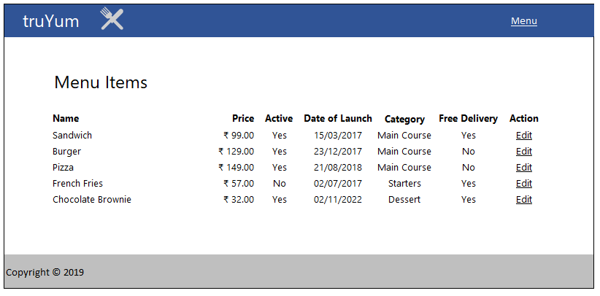

**GetMenuItemListAdmin() of return type List<MenuItem>**

This method returns the list of menu items that will be displayed in the MenuItem listing screen for Admin.

1. Return the menuItemList

## MenuItemDaoCollectionTest.cs

**Main(string[] args)**

1. Invoke TestGetMenuItemListAdmin()

**TestGetMenuItemListAdmin() of return type void**

1. Instantiate MenuItemDaoCollection and assign MenuItemDao reference variable menuItemDao in its object instance.
2. Invoke MenuItemDao.GetMenuItemListAdmin() and obtain the menuItemList
3. Iterate through the menuItemList and display all attributes of each menu item.

# Design for View Menu Item List Customer (EKUC002)

## Class Diagram

The below diagram denotes the methods that needs to be implemented for this use case. Method wise specification is defined after the diagram.

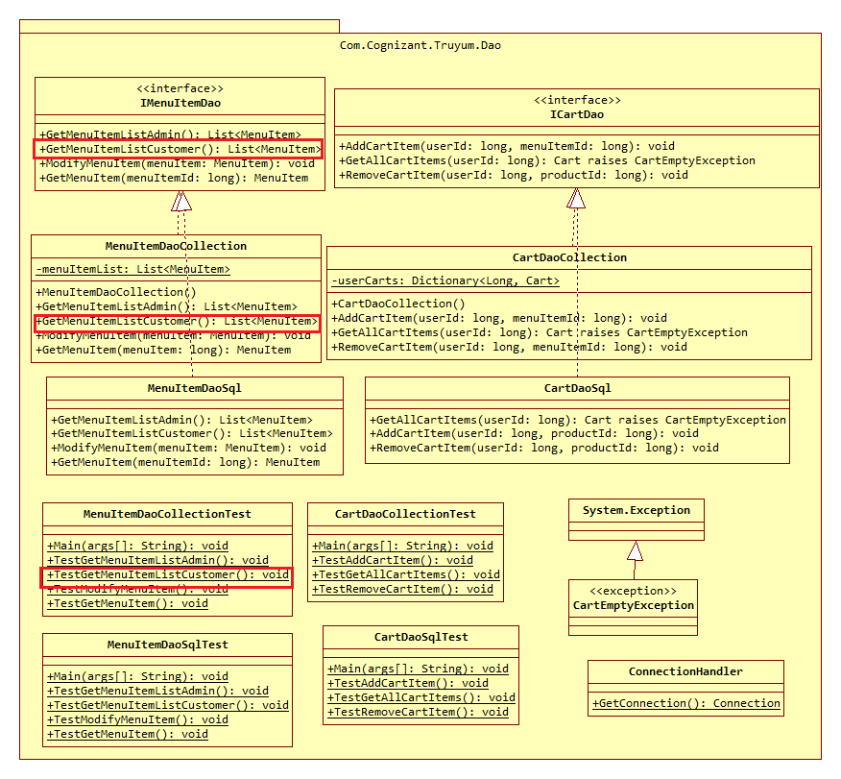

## IMenuItemDao.cs

Add the method GetMenuItemListCustomer() of return type List<MenuItem> in the interface.

## MenuItemDaoCollection.cs

This class manages the data related to Menu Items of truYum application. A new method needs to be added for this use case.

**GetMenuItemListCustomer() of return type List<MenuItem>**

This method returns the list of menu items that will be displayed in the Menu Item listing screen for Customer.

1. Initialize a List for type MenuItem
2. Iterate through menuItemList and perform the following steps:
   1. Is the Date of Launch of the menu item is after current date?
   2. Is the menu item available is active?
   3. If the above conditions satisfy, add the menu item into the List created in the first step.
3. Return the filtered List

## MenuItemDaoTest.cs

**Main(string[] args)**

1. Invoke TestGetMenuItemListCustomer()

**TestGetMenuItemListCustomer() of return type void**

1. Instantiate MenuItemDaoCollection and assign MenuItemDao reference variable menuItemDao to its object.
2. Invoke menuItemDao.GetMenuItemListCustomer() and obtain the menuItemList
3. Iterate through the menuItemList and display all attributes of each menu item.

# Design for Edit Menu Item (EKUC003)

## Class Diagram

The below diagram denotes the methods that needs to be implemented for this use case. Method wise specification is defined after the diagram.

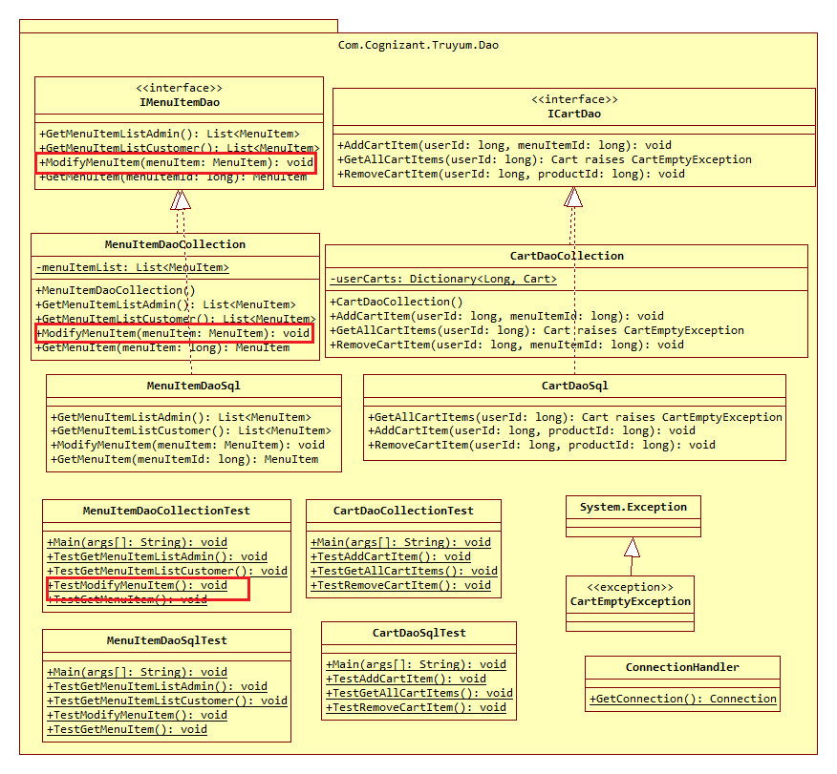

## IMenuItemDao.cs

1. Add method ModifyMenuItem(MenuItem menuItem) **of return type** void in the interface.
2. Add method GetMenuItem(long menuItemId) **of return type** MenuItem in the interface.

## MenuItemDaoCollection.cs

This class manages the data related to Menu Items of truYum application. A new method needs to be added for this use case.

**ModifyMenuItem(MenuItem menuItem) of return type void**

This method will be used to change the menu item data in the list of menu items. This method will be invoked when Customer submits the user form.

1. Iterate through the menuItemList and find the matching menu item
2. Update the matching menuItem in the List

**GetMenuItem(long menuItemId) of return type MenuItem**

This method is used to retrieve a particular menu item’s detail from the menu item list. This method will be invoked when user click on Edit link in menu item listing screen of Admin.

1. Iterate through menuItemList and find the matching menu item
2. Return the matching menuItem from the menuItemList

## IMenuItemDao.cs

**Main(string[] args) of return type void**

1. Invoke TestModifyMenuItem()

**TestModifyMenuItem() of return type void**

1. Create an instance for Menu Item with id matching with one of the menu item already added to the menuItemList.
2. Instantiate MenuItemDaoCollection and assign MenuItemDao reference variable menuItemDao to its object.
3. Invoke MenuItemDao.ModifyMenuItem(menuItem) by passing the menu item created in the first step.
4. Invoke MenuItemDao.GetMenuItem(producId) to read and check if the menu item details are modified.

# Design for Add to Cart (EKUC004)

## Class Diagram

The below diagram denotes the methods that needs to be implemented for this use case. Method wise specification is defined after the diagram.

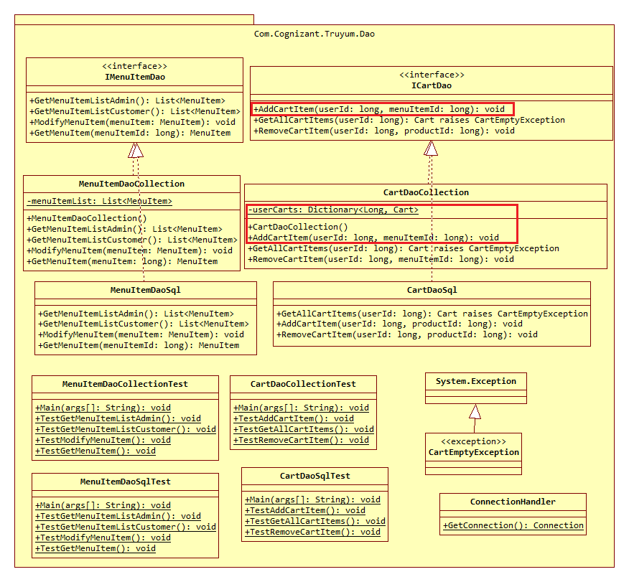

## ICartDao.cs

1. Add method AddCartItem(long userId, long menuItemId) **of return type** void in the interface.

## CartDaoCollection.cs

This class manages the data related to Cart of all users of truYum application. A new method needs to be added for this use case.

**Constructor CartDaoCollection()**

Data for all users will be stored in the Dictionary available in Cart instance. This constructor initialized the Cart as well as the Dictionary within the Cart, so that the class instance is ready to store values in the Dictionary when Customer adds items into the Cart.

1. Check if the userCart instance variable is null or not
2. If userCart is null then create a new instance of Dictionary with type Long and Cart and assign it to userCart instance variable.
3. The userCart instance variable will hold the cart details for each user in a Dictionary. The key of this Dictionary will have the userId. Each value in the Dictionary will be the Cart item that internally contains the list of MenuItems.

**AddCartItem(long userId, long menuItemId) of return type void**

This method is invoked when Customer clicks Add to Cart link in menu item listing screen. This method gets the Cart from the Dictionary for the specific user and adds the menu item into the cart’s menu item list. If there is no such user in the Dictionary, then a new entry needs to be added in the Dictionary with userId as key and new Cart item with a List of Menu Items as value.

1. Instantiate MenuItemDaoCollection and assign MenuItemDao reference variable menuItemDao to its object.
2. Get the menuItem using menuItemDao.GetMenuItem(menuItemId) method
3. Check existence of user in userCart based on userId
4. If user exists in userCart, perform the steps below:
   1. Get the menuItemList from the userCart
   2. Add the menuItem obtained in previous step into menuItemList
5. If user does not exist in userCart, perform the steps below:
   1. Create a new Cart instance with new List
   2. Add the menu item obtained in step one and add it to menuItemList created in previous step
   3. Put the userId and List of MenuItem into the userCart

# Design for View Cart (EKUC005)

## Class Diagram

The below diagram denotes the methods that needs to be implemented for this use case. Method wise specification is defined after the diagram.

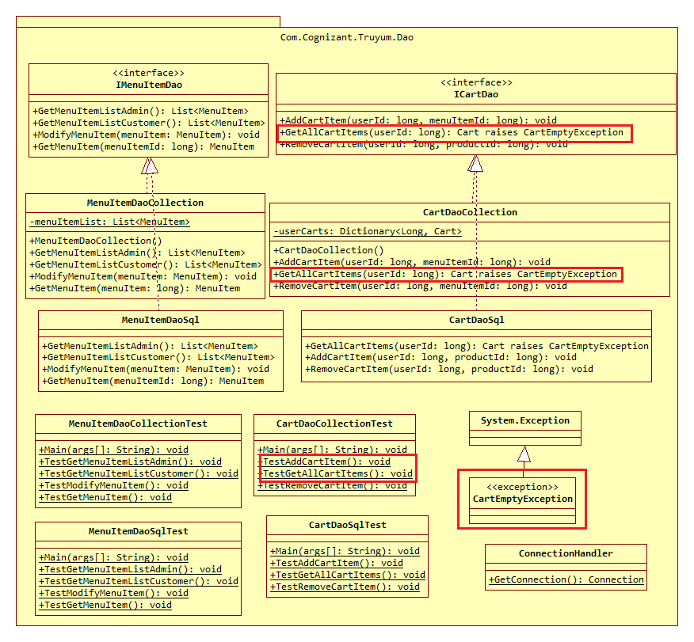

## ICartDao.cs

1. Add method GetAllCartItems(long userId) **of return type** void in the interface.

## CartEmptyException.cs

1. Extend this class from System.Exception and include an empty constructor.

## CartDaoCollection.cs

This class manages the data related to Cart of all users of truYum application. A new method needs to be added for this use case.

**GetAllCartItems(long userId) of return type Cart throws CartEmptyException**

Method to get list of menu items added by a customer to Cart.

1. Get the menuItemList based on userId from the Dictionary of userCart
2. If the returned list is empty
   1. Create new CartEmptyException and throw it
3. If the returned list is not empty
   1. Iterate through the menuItemList and add up the prices.
   2. Set the total instance variable of cart with the added up menu item prices.
   3. return cart

## CartDaoCollectionTest.cs

**Main(string[] args) of return type void**

1. Invoke TestAddCartItem()

**TestAddCartItem() of return type void**

1. Instantiate CartDaoCollection and assign CartDao reference variable cartDao to its object.
2. Invoke CartDao.AddCartItem() method with following parameters
   1. userId: 1
   2. menuItemId: one of existing menuItemId in MenuItemDaoCollection
3. Invoke CartDao.GetAllCartItems() with userId as 1
4. Display the contents of MenuItemList returned in previous step and check if the added cart item is present or not.

# Design for Remove Cart Item (EKUC006)

## Class Diagram

The below diagram denotes the methods that needs to be implemented for this use case. Method wise specification is defined after the diagram.

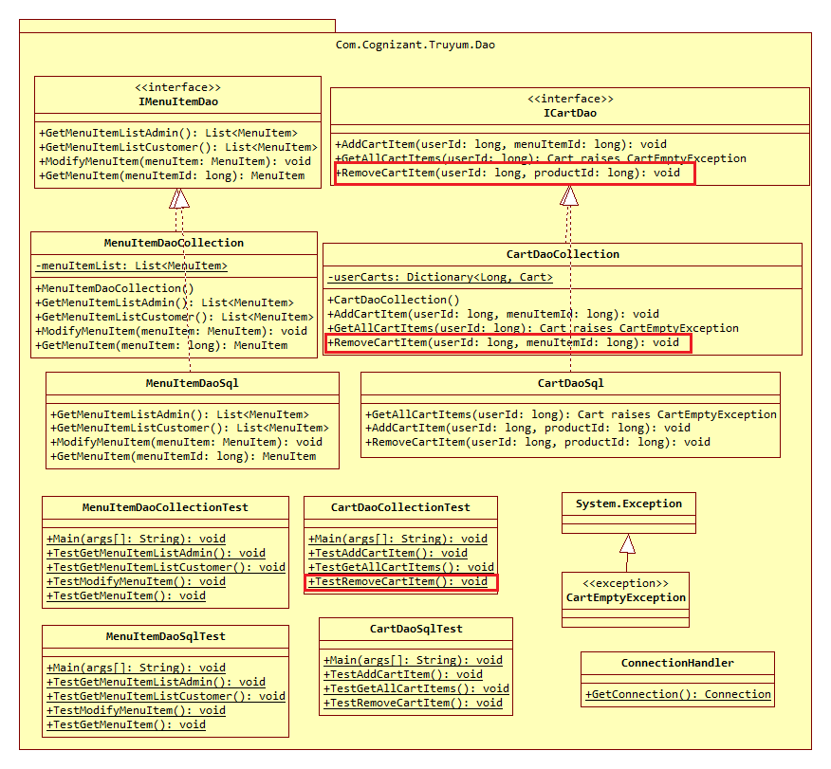

## ICartDao.cs

1. Add method RemoveCartItem(long userId, long menuItemId) of return type void in the interface.

## CartDaoCollection.cs

This class manages the data related to Cart of all users of truYum application. A new method needs to be added for this use case.

**RemoveCartItem(long userId, long menuItemId) of return type void**

Method to remove a menu item from the cart. This will be invoked when Customer clicks Delete link in the Cart screen.

1. Get the List<MenuItem> from userCart based on userId
2. Iterate through the List of MenuItem and perform the below steps
   1. Check if the menuItemId of each menu item from the list matches with this methods input parameter
   2. If menuItemId matches then remove the menu item from the list

## CartDaoCollectionTest.cs

**Main(string[] args) of return type void**

1. Invoke TestRemoveCartItem()

**TestRemoveCartItem() of return type void**

1. Instantiate CartDaoCollection and assign it CartDao reference variable cartDao.
2. Invoke CartDao.RemoveCartItem() method with following parameters
   1. userId: 1
   2. menuItemId: Same menuItemId as what was provided when testing add cart item.
3. Invoke CartDao.GetAllCartItems() with userId as 1
4. Enclose the above method within try catch block with catch block handling CartEmptyException. Check if the catch block is executed, which means that the cart item added during TestAddCartItem() is removed now and the cart is empty, due to which the CartEmptyException is thrown.

# Standards and Guidelines

## C#

1. Naming standards to be followed:
   1. Variable/parameter:
      1. Camel casing should be followed for naming variables/parameters
      2. Variable names should be short, but meaningful
      3. Single character variable names should be avoided except for temporary variables
      4. Avoid using single character for naming variables/parameters
   2. Class
      1. Pascal casing should be followed for naming classes
      2. Class name should be a noun
      3. Must use whole words and should not have acronyms or abbreviations

Examples: Employee, TaxCalculator

* 1. Method
     1. Pascal casing should be followed for naming methods
     2. Must use whole words and should not have acronyms or abbreviations

1. Code Formatting
   1. Class Structure
      1. Place the elements of a class in the following order:
         1. Static variables
         2. Instance variables
         3. Constructors
         4. Methods and Getter/Setters
   2. Spacing
      1. A space before and after an operator is required
      2. A space before curly braces is required
      3. A space after a comma is required
      4. A space after semicolon in for loop is required
      5. A single line space after a method is required
   3. Curly braces position
      1. Opening curly braces should be in the same line
      2. Closing curly braces should always be in a new line
   4. Tab spacing
      1. Use 4 spaces instead of tab character
      2. Increase a tab character in the lines after opening curly braces
      3. Reduce a tab character on the of closing curly braces
      4. Include one more tab in the wrapped line
   5. Line Width
      1. Width of a line should not exceed 100 characters

# Console application to test C# class library ( Com.Cognizant.Truyum.Model & Com.Cognizant.Truyum.Dao )

1. Create a Console application project – **TruYumConsole**
2. Reference the **Com.Cognizant.Truyum.Model & Com.Cognizant.Truyum.Dao** class library projects in TruYumConsole application
3. Invoke the methods of the Com.Cognizant.Truyum.Model & Com.Cognizant.Truyum.Dao from the TruYumConsole application
4. For C# testing, please set up the TruYumConsole application as the startup project

Post completion of above steps:

1. Ensure to commit **Com.Cognizant.Truyum.Model & Com.Cognizant.Truyum.Dao** class library projects to GIT repository.
2. Ensure to commit **TruYumConsole** Console application project to GIT repository.

# Submission

## Code submission instructions

Once your code is evaluated by the trainer and all the issues reported by the trainer are corrected, the code needs to be submitted to the remote repository. Follow the steps below to submit the code to remote repository.

1. In Windows Explorer go to the truYum folder
2. Right click on the empty space in the right-hand side of Windows Explorer and select “Git Bash here”
3. Execute the following commands

To display the added or modified files

git status

To stage the added or modified files

git add .

To display the staged files

git status

To save the code to local repository

git commit -m "C#"

To transfer the changes from local machine to server

git push origin master

1. Successful execution of the above commands will upload the files to the server repository.
2. Login into <https://code.cognizant.com>
3. Click on the project truYum
4. Check if the files that are uploaded correctly with appropriate folder structure.

# Change Log

|  |  |  |  |  |
| --- | --- | --- | --- | --- |
|  | Changes Made | | | |
| V1.0.0 | Initial baseline created on 20-May-19 by Ramamoorthy Selvam | | | |
| Vx.y.z | <Please refer the configuration control tool / change item status form if the details of changes are maintained separately. If not, the template given below needs to be followed> | | | |
| **Section No.** | **Changed By** | **Effective Date** | **Changes Effected** |
|  |  |  |  |